Information Systems Class notes 21st March.

IT vs IS : technology can be broken down into infrastructure and hardware whereas IS is how we pull the tech together and manage data storage. Its unique to each organisation

IS are interrelated components working together to collect and store and process data to support decision making, control, analysis and visualisation in an organisation.

Info is knowledge about the world around us that is sought out by people to satisfy their psychological needs on the basis of which they can take action or make decisions.

This definition suggests that people value information because they seek it out to use it because it tells us the situation.

While information is valuable on its own, it is also based on a number of characteristics such as reliable and accurate, accessible, updated and timely, conveniently presented, the appropriate level of detail, reduces uncertainty, exclusive, pleasing to evoke a direct response from the receiver and enables another valued task.

Generally, the cost of collecting and interpreting data to deliver is significant. This is because the business or entity will need to use various types and amounts of resources including people and technology to produce, manage and distribute the information.

Socio-technical   
a combination of concern and consideration for people, what they do and want – and technology concerns.

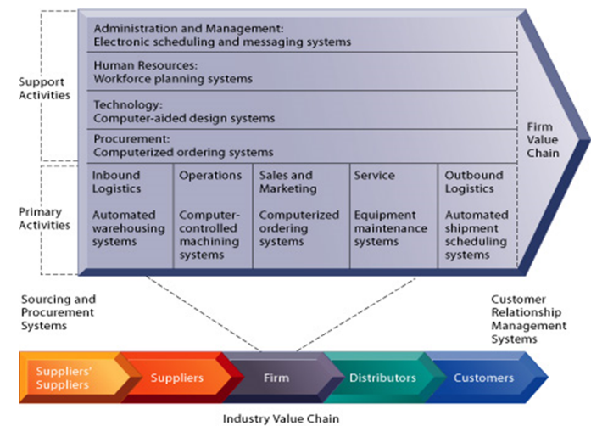PORTERS VALUE CHAIN WITHIN FIRMS

Each step in an organisation operation adds value and benefits the next group.

* DIFFERENT ORGANISATIONS
* Purpose
* Industry category and type
* Legal status
* Organisational structure

PURPOSE  
Not knowing the purpose will make it difficult in the future as you will struggle to differentiate between good and bad opportunities and define a strategy to achieve them. One way to define a purpose is to define the mission statement and goals.

Mission Statements and Goals  
Mission Statement – how a business will achieve its purpose as well as communicate the business purpose and main goal for consumers to understand.  
Vision – inspirational description of the desired future of the business

Goals and Objectives  
Performance targets that are used to measure success or failure.

“An effective mission statement defines the fundamental, unique purpose that’s sets a business apart from other firms of its type and identifies its scope”  
it’s a statement that reveals the business product/service, markets, customers and values.

Mission statement elements  
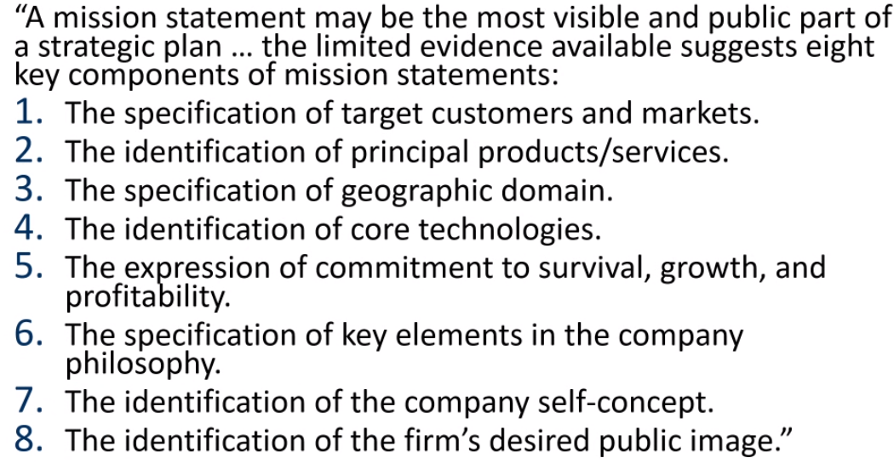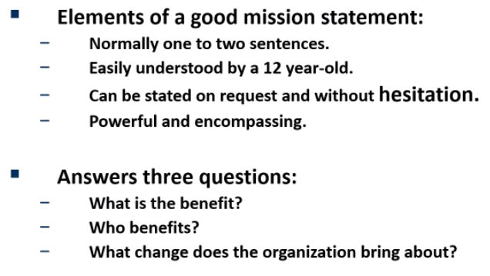

What is business industry description?  
it’s a way of clarifying a business by the main activity its involved in. e.g. ACC uses business industry descriptions and their related BIC codes to determine which of ACCs classification unites will apply for levy invoicing.  
Describing the Organization  
By complexity: Organisation Structure, is it matrix(flat) or hierarchical(chain of command)

Goals  
goal settings provide direction and guidance for managers. Helps firms allocate resources. Helps define corporate culture and assess performance.

Vision is why and how. Mission is what and who. Objectives and goals in the company will change as they achieve them or prioritize them so the vision statement should be revised regularly as needed to the reflect changing business goals as each goal is met.

Core Values  
core values are fixed regardless of time and factors, affecting the organisation while strategies and practices should be frequently changing.

ORGANISATIONAL STRUCTURE

This defines how activities such as task allocation, coordination and supervision are directed toward the achievement of organisational aims. This affects organizational action in two main ways

* Firstly, it provides the foundation on which standard operating procedures and routines rest.
* Secondly, it determines which people get to participate in the decision-making process and to what extent their views shape the organisations actions.

An example of this would be changing cubicle meetings to a large table where employees can communicate together toward the same task , in a different fashion.

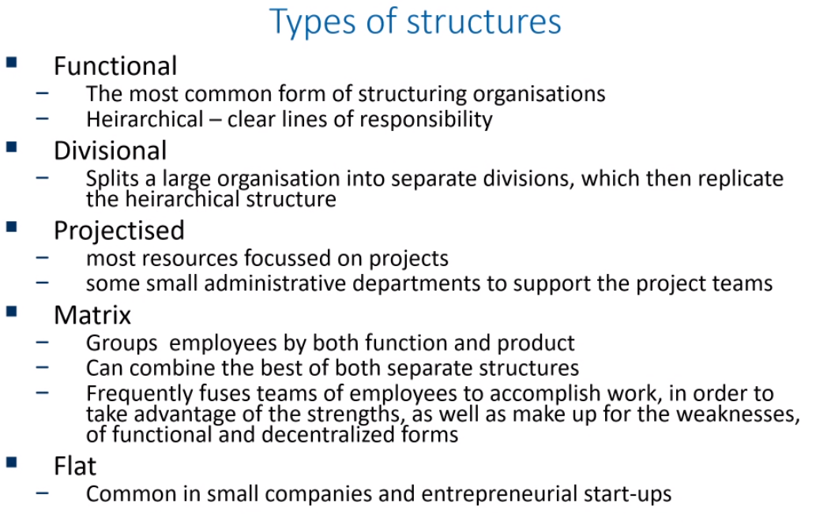

Span of Control – the area of activity and number of functions, people, or things that an individual or organization is responsible for.

**Span of Control: two dimensions**

The Span of Control always involves two dimensions:

**Horizontal dimension**

This is the number of direct subordinates a manager supervises. This is also referred to as Span of Control.

**Vertical dimension**

This is the number of levels that are (in)directly managed. It refers to the extent to which the manager’s wishes trickle down to the lowest levels of the organisation. This is also known as **Depth of Control**.

It is mainly aimed at the extent of communication between a manager and his subordinates in the levels he is responsible for. Without a good leader, downward communication can be impaired.

Exercise – Identify the main elements of These organisations.

Warehouse  
Purpose: To deliver the things kiwis need, enabling sustainable living at an affordable price.

Industry Category: Retail

Size: Large

Legal Status: Limited Liability Company

IT Needs: POS system, Networks, Administrative support, applications, voice and video communications, data storage, Internet and EDI. Support Governance.